12.22: a) From Example 12.4 the mass of the lander is 4000 kg. Assuming Phobos to be spherical, its mass in terms of its density 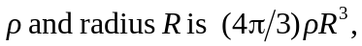 and so the gravitational force is

b) The force calculated in part (a) is much less than the force exerted by Mars in Example 12.4.

